Content of the Training Fiche
Training course 1
Quest 1 3
Quest 2 6
Quest 3 8
Educator tips 11

Training course
Title | Technical and 3D Drawing
Area | Technical and 3D drawing X  Business management and entrepreneurship  Social Media Management  Self-awareness and self-efficacy & Critical Thinking and growth mindset
Keywords (meta tag) | Fablab, 2d and 3d drawing, Inkscape,
Provided by | Húsavík academic center
Language | English
Description | [description of the course; around 200 characters]
Contents arranged in 3 levels
Module: [title]

Unit 1: Introduction
What is Fablab
If you have a FabLab close by you can use these instructions to guide you in your first steps. You can also use these instructions at home with your own computer

Fab Lab comes from the English words Fabrication Laboratory, a kind of manufacturing laboratory. Fab Lab has its roots in the Center for Bits and Atoms at MIT University in Massachusetts, USA. That institute is headed by Professor Neil Gershenfeld who, in addition to conducting extensive research in this field, teaches a course at MIT called How to Make (Almost) Anything.
Fab Lab (Fabrication Laboratory) is a workshop with equipment and tools to make almost anything. The Fab Lab workshop gives young and old, individuals and companies, the opportunity to train their creativity and implement their ideas by designing, shaping and producing things with the help of digital technology.

Radical changes in society and the economy call for changes in education. Education and skills in trades, science and technology are an important basis for innovation.
We want to be doers in the digital future. We want to create new jobs, new opportunities and activate the possibilities offered by new technologies..

Fab lab is an open platform for the public, companies, entrepreneurs, and students. Fab Lab is a workshop with devices and tools to make almost anything. In FabLab include; computerized laser cutters, vinyl cutters, milling machines, 3D scanners and 3D printers

What equipment is in Fab Lab workshops?
All Fab Lab workshops are equipped with various types of equipment to generate all kinds of ideas.
All workshops have laser cutters, large milling machines, fine milling machines, 3D printers, electronics workshops, have 3D scanning facilities, remote conferencing equipment and 2D and 3D design equipment along with programming equipment. This tutorial covers how to use 3d printing and some of its equipment.

Section 2: Software to draw 2D and 3D drawing
Many options are for software to draw such as: 2D drawing, Inkscape, it is easy desktop app for creating cutting files. Gimp is a free image editor.
In 3D drawing we introduce Tinkercad, a free web app for 3d design, electronics and coding. Blender is also free and open-source 3D computer graphics software tool.

What is the difference between 2d and 3d?
2D (two-dimensional) drawings describe objects in terms of length and height on a flat surface without depth.

3D (three-dimensional) drawings describe objects in terms of height, width and depth.

Section 3: Inkscape
What is Inkscape?
Inkscape is a professional quality vector graphics software.
Widely used for both artistic and technical illustrations such as cartoons, clip art, logos and typography.
It uses vector graphics to allow for sharp printouts and renderings at unlimited resolution. They do not lose any quality if they are zoomed or resized.
Inkscape is free and open source
Inkscape uses the standardized SVG file format as its main format
You can import and export various file formats, including SVG, AI, EPS, PDF, PS and PNG.

Get to know it
Keyboard Shortcuts for Inkscape
There are many shortcuts, commands you can learn as you go along.

First let’s get an overview of the software and its basics. Try them as we go along and then check out our quests.
This software has many possibilities.
Take one step at the time.
Often there are more than one way to achieve the same result.
Soon you will develop your own habits and preferences for
drawing with Inkscape.

Menu bar: along the top, general menu options
Commands bar: quick access to common commands.
Toolbox: on the left, main drawing tools. Only one tool can be used at once.
Tool controls bar just below to adjust the currently selected tool
Canvas : the large blank area where the image is edited.
Page area: A black/white outline represents it
Docking area: dialogs for specific functionality

Ways of drawing in Inkscape

Inkscape offers several ways for creating vector images, which can, of course, be combined:
- using the geometric shape tools
- using the path tools, much like a pencil on paper
- using one of the many available features that let you create elements of a drawing automatically
- starting from a photo, a scanned/copied image or any raster graphic by using a tracing engine

The Shape Tools is used to create a geometric shapes:
- Start by selecting the tool in the toolbar by clicking on it. Then press the mouse button and hold while you drag the mouse on the page area. Then release the mouse button to display the shape.
- Once the mouse button is
released and the shape is
displayed, various handles
will become visible. Many of
Inkscape’s tools use handles for one purpose or another.

Free drawing
Pencil, Pen and Calligraphy tools
With some practice, you will get better and better in achieving exactly the result that you desire.
The freehand drawing tools make it possible to draw directly onto the Inkscape canvas.
Depending on what and how you would like to draw, you can select the best tool for the task.
These tools are not based on geometrical shapes. You can draw exactly the shape you need. And of course, you can always modify the elements in your drawing with the path tools.
The selector tool
Transformations (such as moving, scaling, rotating) are easy thanks to the two-way arrows.
To select more than one object:
- press the mouse button
and drag out a selection
box with all the
objects.
To scale (change the size of) an object:
- click on it to select it; then press the mouse button a two-way arrow on a side or a corner and hold while dragging it to the desired size
If you want to preserve the proportions hold Ctrl or use the lock in the tools control bar

Section 4: 3D drawing – Altering 3d & design
Tinkercad and Meshmixer

Simply sign in
Tinkercad is a 3D CAD program from Autodesk that is easy to use and suitable for e.g. designing small simple parts for 3D printing.

In the Fab Lab workshops, Tinkercad is mostly used to design objects in 3D to be printed on a 3D printer. In Tinkercad you can also import files on e.g. .svg format and convert to 3D and you can also import 3D files in .obj or .stl format and continue working with those files in Tinkercad.

The program is in the on the web and can be used with a browser at https://www.tinkercad.com/.

Teachers can get a special access code that they can pass on to their students in order to use the application.

Endless Possibilities
Basic models such as name tags, furniture, houses, snowmen, vases, keychains, and
cups are easy to create quickly with Tinkercad.

Design by selecting, dragging, and placing basic shapes and then combining and
manipulating them to create 3D models of whatever you like.

If you make your designs public then other people can open their own copies of your
models and Tinker with them; likewise, you can Search through thousands of public
models to find designs to Tinker with and modify.

Learning centre
After you have signed in on Tinkercad you can go to Resources on top of the page and choose the Learning centre (tinkercad.com/learn). In the learning centre you can get started learning how easy and fun Tinkercad really is.

Meshmixer
Just download and start
Meshmixer is another 3D program from Autodesk. It's easy to use and well suited for preparing existing files for 3D printing.
It works with the most common mesh formats (.stl, .obj, .ply, .amf, .3mf, .off and .mix), which opens a whole new world of accessible 3D models online. Download the desired file(s), adjust to your wishes and you are good to go.

The program has to be downloaded to your computer.
It's suitable both for Windows and Mac OS.
Download here: https://meshmixer.com/

Meshmixer is no longer in development, but won't retire anytime soon. Most features are available in Fusion360, too. Fusion 360 is fee-based.

There are three different methods with video tutorials:
- Learn 3D Design
- Learn Circuits
- Learn Codeblocks

Endless possibilities
Opposite to Tinkercad you don't create shapes in Meshmixer but alter and combine
ready designs.
There's a huge amount of printable designs online, a good free selection to be found at
https://www.printables.com/

Combine different designs, vary size and structure at your likings. No limits!

With the included Inspector-tool you can detect faulty areas, define the problem and repair in one step to make your design printable.

There is a big community using Meshmixer and uncountable tutorials online, everything from the very start to advanced models. Autodesk itself hosts a Meshmixerforum.
Tutorials:
- All3DP
- Solidprofessor
- 101 Meshmixer (YouTube)

Section 5: Quest and self assessment

5 glossary entries
Software. Software is a set of instructions, data or programs used to operate computers and execute specific tasks. It is the opposite of hardware, which describes the physical aspects of a computer. Software is a generic term used to refer to applications, scripts and programs that run on a device.

Digital technology. Digital technologies are electronic tools, systems, devices and resources that generate, store or process data. Well known examples include social media, online games, multimedia and mobile phones. Digital learning is any type of learning that uses technology.

2D (two-dimensional) drawings:​ describe objects in terms of length and height on a flat surface without depth.​
​
3D (three-dimensional) drawings: describe objects in terms of height, width and depth.

Vector images: is a form of digital images created with mathematical equations, points, lines, and curves and the images can be made larger or smaller without losing resolution. Vector files are an alternative to Raster files that are composed of a fixed number of square pixels.

Bibliography and further references
https://fablab.is/
https://www.tinkercad.com
https://meshmixer.com/
https://inkscape.org/

Five multiple-choice self-assessment questions
Question 1: What is fablab:
a) A place to play
b) A place to create
c) A place to learn and invent
d) All above

Correct option: d

Question 2: In Inkscape you can only do 2D design:
a) Right
b) Wrong

Correct option: b

Question 3: For sharp printouts and renderings at unlimited resolution Inkscape uses:
a) HP format
b) Vector file format
c) Word
d) JPEG format
e) DND format

Correct option: b

Question 4: Tinkercad is:
a) For professionals
b) Deigned for kids
c) For all ages and all stages
d) For beginners

Correct option: c

Question 5: In Meshmixer you:
a) Build shapes
b) Alter and combine ready designs
c) Draw 2d designs
d) Need to be a professional

Correct option: b

Related material |  | [related material if any]
Reference link |  | [reference link if any]
Video in YouTube format (if any) |  | https://www.youtube.com/watch?v=hrQ8sFfAnyA&ab_channel=AutodeskTinkercad

Quest 1
Quest title | Easy text on path in Inkscape
- Introduction: What’s this all about?
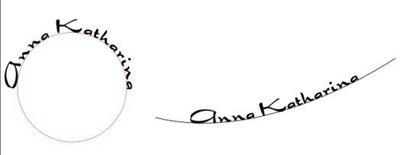
Drive URL of the image
Image title (including copyright information) |  | Easy text on path in Inkscape
Do you have permission to use this image? |  | Our own photo  YES
Introduction text
In this quest you will learn to set up an easy text on path in Inkscape. By doing so you will get to know the software. This is a good practice before you make your own sing/sticker with your name on it. Follow the instructions this time, because it is always good to get help to begin with.
- Task: What’s the activity?
Activity image
Drive URL of the image
Image title (including copyright information) |  | Easy text on Path  (CC HAC)
Do you have permission to use this image? |  | Yes. This image was made by HAC in Inkscape.
Activity text
Now you have seen the basics of Inkscape. Let's try it out. This way you will get to know the software one step at the time. You will get more familiar with Inkscape, learn how to use the tool to make text
- Process: What am I going to do?
How to make a sign/sticker with your name on it
- Open Inkscape and hit the "A" in the taskbar on the left side. It's to create and edit text.
- Now you can draw a frame wherever you like on your page. You are going to write into that frame.
Double click and write your name. The font doesn't matter right now.
Now choose a font you like in the Tool controls bar.
- Now choose a font you like, but no handwriting or script as the vinylcutter would cut your sticker into pieces instead of having a whole piece. I chose "Dragonfly". There are a lot of free fonts online e.g. at www.1001freefonts.c

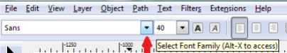

- Next step is to draw a path to put your text on. The path will be defined to form your text.
You can choose between drawing a path yourself or using a predefined form like a circle, ellipse, star, rectangle or even a spiral. The icons are in the taskbar on the left. Don't be shy to try out different
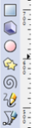

If you want to get a perfect circle, make sure to have the same value in the fields "W" (width) and "H" (height). If necessary, open the padlock and then close it again after changing the values to make sure to keep the right aspect ratio.
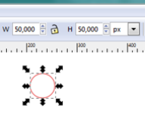
When drawing a star or polygon you can among other things choose the number of corners. Choose at least 2 forms to try out, maybe a predefined and a hand drawn.
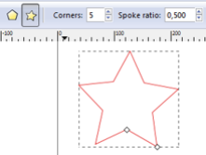

Select your text, copy and paste it in your document.
Pick your text and then hold the SHIFT-button to select the form/path you want to put your text on.
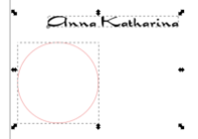
Go to the taskbar on top, choose "Text" and "Put on path" in the dropdown menu.
Now your text and form are combined. You can move the text away from the path, but it will keep its new form. If you are not happy with the look, you can move the text with the spacebar or in my case just turn the form with the handles until everything is the way you want it to be.
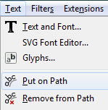

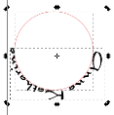

Then put the other text on another path. Compare your results and then choose which one you want to keep.
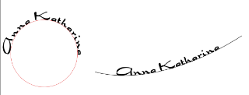
As you don't want the vinylcutter to cut the line/path, too, you have to make it invisible. If you delete the path, the text will return to its previous form. To make the path invisible, hit "Fill and Stroke" and then mark the "X" at "Stroke paint".
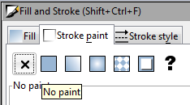
Now its time to save and close your file
- Learning outcomes: What will I learn?
Knowledge Acquired |  | - You will learn how to make a text in Inkscape  - You will get insight to the basics of Inkscape
Skills Acquired |  | - You will improve your Digital content creation  - You will increase your Creativity  - Improve your skills for problem solving
Attitude Acquired |  | - You will increase your entrepreneur's mindset  - You will your imagination and abilities to identify opportunities for creating value  - Increase your creative and purposeful ideas
- Conclusions: What will I take home?
What did you think about Inkscape? This software looks complicated at first but as soon as you try it, it will all make sense. Now you have finished your first project in Inkscape and you can try a new project on your own.
We recommend that you look at some tutorials on the Inkscape.org web page and keep on practicing.
6: Resources: What do I need?
Websites (URLs) |  | Inkscape hompage
 |  | https://inkscape.org/
 |  | Basic tutorial
 |  | https://inkscape.org/doc/tutorials/basic/tutorial-basic.html
 |  | Inkscape app
 |  | https://apps.microsoft.com/store/detail/inkscape/9PD9BHGLFC7H
Videos (from YouTube) |  | Interface and basic drawing
 |  | https://www.youtube.com/watch?v=8f011wdiW7g&list=PLqazFFzUAPc5lOQwDoZ4Dw2YSXtO7lWNv&ab_channel=TJFREE
 |  | Tutorial for beginners
 |  | https://www.youtube.com/watch?v=-_KJZPOYBeA&ab_channel=SkillsFactory
Documents |  | Inkscape manuals for downloading
 |  | https://inkscape-manuals.readthedocs.io/en/latest/

Quest 2
Quest title | Change a bitmap into a vector graphic
- Introduction: What’s this all about?
Introduction image
Drive URL of the image |  | https://www.vectorstock.com/royalty-free-vector/flower-silhouette-stock-vector-37032917
Image title (including copyright information) |  | Vectorstock.com
Do you have permission to use this image? |  | YES: free for commercial use, no attribution required
Introduction text
In this quest we will continue to use Inkscape and learn about its possibilities by using it.
You will change a bitmap into a vector in a simple way and learn how to use the internet to search for the right picture.
- Task: What’s the activity?
Activity image
Drive URL of the image |  | 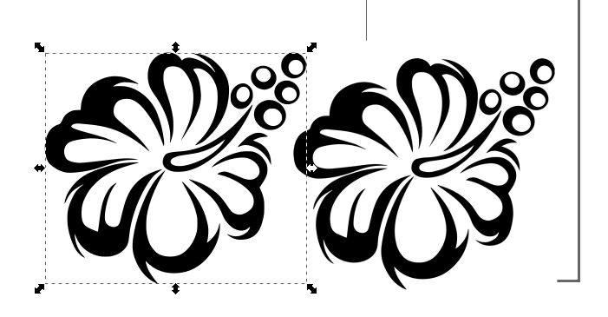
Image title (including copyright information) |  | Change a bitmap into a vector graphic
Do you have permission to use this image? |  | (Copyright free, Creative Commons, or your own photo?)  YES / NO
Activity text
In this quest you will change a bitmap into a vector graphic, that is to change a simple online photo into a vector graphic. Follow these instructions and make a simple vector for yourself. You will learn how to change a bitmap into a vector graphic.
- Process: What am I going to do?
In this quest you will change a bitmap into a vector graphic, that is to change a simple online photo into a vector graphic.
Find a picture on the internet via a search engine like Google. Best for the start is to search for clipart's or logos in just 2 colours e.g. black and white.
For example I searched for „flower clipart black white”
When choosing a pic, take care it is in sufficient size The bigger the more details you get when tracking the bitmap in Inkscape.
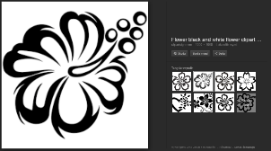

Open the pic with the „View Image“ button. You get it in a better resolution there.
Copy the pic. Attention: if the pic is a .png file, please save the file to your computer instead of copying it. If you just copy it, you‘ll get a black rectangle instead of the pic when pasting it to Inkscape.
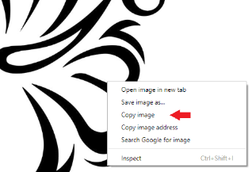
Open Inkscape and paste the pic. It doesn‘t matter if the pic fits on the page displayed in Inkscape or not. No need to change the page layout.
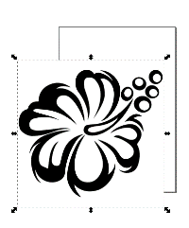
Make sure your pic has the frame like shown above. This means the pic is „active“ and we can work with it. If you want to change size by pulling the handles, take care to close the lock shown on the pic below.
When this is locked, both height and width change at the same time, keeping the pic at the right aspect ratio.
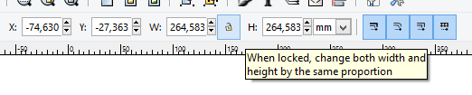
If you‘d like to zoom in or out, use the zoom at the very right lower corner.
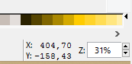
Next (after making sure your pic is active) you open the pull down menu „Path“ and click on „Trace Bitmap“.
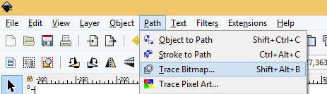
A new window opens. Tick off the box at „Live Preview“ so you can see the changes in your pic when you change the value in „Threshold“.
With clear pics like our example it is best to use „Brightness cutoff“ to change it into a vector graphic.
The standard value at „Threshold“ is 0,450. If you increase the number, the pic gets darker, taking in more details. If you decrease it, there will be less details, but less interruption if you take a more complicated pic in different colour.
Best try out a few different settings and decide then, which fits best for you at that very moment.
When you are happy with the preview, hit the OK button.
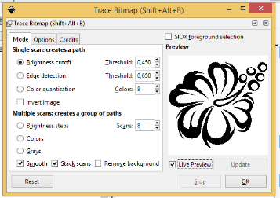
Now your vector graphic is above your original pic and you have to move it to the side to see the results.
You should have gotten a pic with clearer outlines, no pixels.
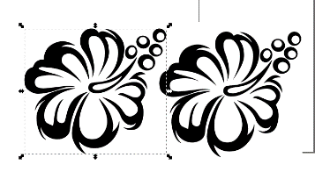
If you are content with the results, delete the original pic. In case you are not sure which is the vector graphic and which is the original, hit the button „Edit paths by nodes“ and click on the pic. If it‘s the vector, you‘ll get a lot of little nodes(boxes) on it.
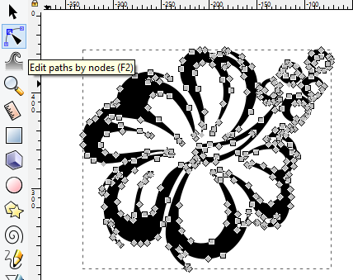
If you want, you can delete nodes in order to get a smoother pic. To do so, click on the node you‘d like to delete and hit the delete button on your keyboard.
The blue/yellow node on the pic is active. You can delete it or move it around.
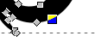
When the pic is the way you want it, you have to take the fillcolour and set the strokecolour instead to see which lines you vinylcutter would cut later on.
To get to the „Fill and Stroke“ menu, choose „Object“ in the taskbar.
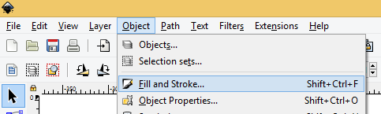
A new window opens with 3 charts on it. The first one is „Fill“, then „Stroke paint“ and the last one „Stroke style“. We are going to use the first two.
In „Fill“ you choose the X, which means, „no fill“. Your pic seems to disappear. Then you change to the next flip „Stroke paint“ and choose the completely filled box. Now the outlines of your pic should appear again.
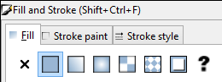
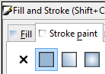

That‘s the way our sample pic looks like now. It‘s ready for the vinyl cutter.
Please keep in mind to save your progress so it won‘t be lost if something unexpected happens during work.
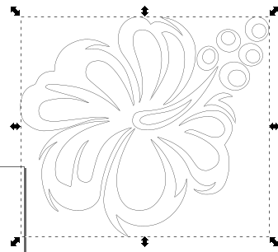
If you delete something by accident or are not happy with the changes you made, use the „Undo-button“ or the shortcut „Ctrl+Z“
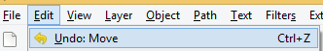

- Learning outcomes: What will I learn?
Knowledge Acquired |  | - You will learn to change bitmap into a vector graphic  - You will create and edit digital content  - You will understand and adopt new ideas, approaches, tools, and actions in response to changing contexts
Skills Acquired |  | - You will improve your information and data literacy.  - You will increase your digital content for creation
Attitude Acquired |  | - You will increase your entrepreneur's mindset  - You will your imagination and abilities to identify opportunities for creating value  - Increase your creative and purposeful ideas
- Conclusions: What will I take home?
Wasn't it fun to make your first vector? It can be overwhelming to begin with to complete projects, so we start with simple tasks.
Now that you know the basics it is ideal for you to practise on your own. We recommend that you look at some tutorials as you go along with more complicated tasks.
6: Resources: What do I need?
Websites (URLs) |  | Inkscape hompage
 |  | https://inkscape.org/
Basic tutorial
https://inkscape.org/doc/tutorials/basic/tutorial-basic.html
Inkscape app
https://apps.microsoft.com/store/detail/inkscape/9PD9BHGLFC7H

Videos (from YouTube) |  | Trace bitmap tools
 |  | https://www.youtube.com/watch?v=E7HwLTQu2FI&ab_channel=TJFREE
Documents |  | Inkscape manuals
 |  | https://inkscape-manuals.readthedocs.io/en/latest/

Educator tips
The software discussed here changes and upgrades regularly, so it is important to follow those changes and show students that development is normal, and they need to be aware of this.
For some students, it is important to see how you can go back and that making mistakes is a normal part of learning new skills.
There are many types of guidance on the internet and for some it is important to access material to learn even more

Quest 1: In this quest you will learn to set up an easy text on path in Inkscape. By doing so you will get to know the software. This is a good practice before you make your own sign/sticker with your name on it. Follow the instructions this time, because it is always good to get help to begin with.

Quest 2: In this quest we will continue to use Inkscape and learn about its possibilities by using it. You will change a bitmap into a vector in a simple way and learn how to use the internet to search for the right picture.

Additional resources (videos, extra material)

